**Headset Instructions**

**1) Put on the throat microphone – as high on your neck as you can place it.**

**2)Put on the headset – speakers just in front of your ears.**

**3) Push the ‘Headset’ button on the phone to answer the call.**

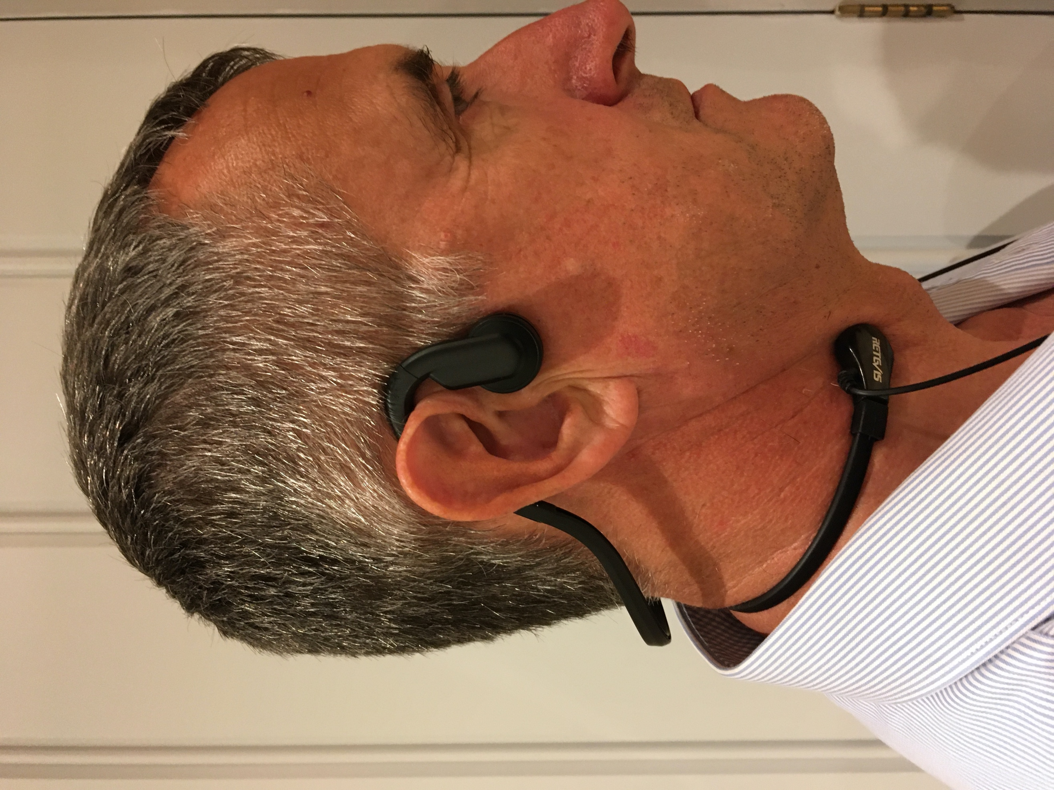

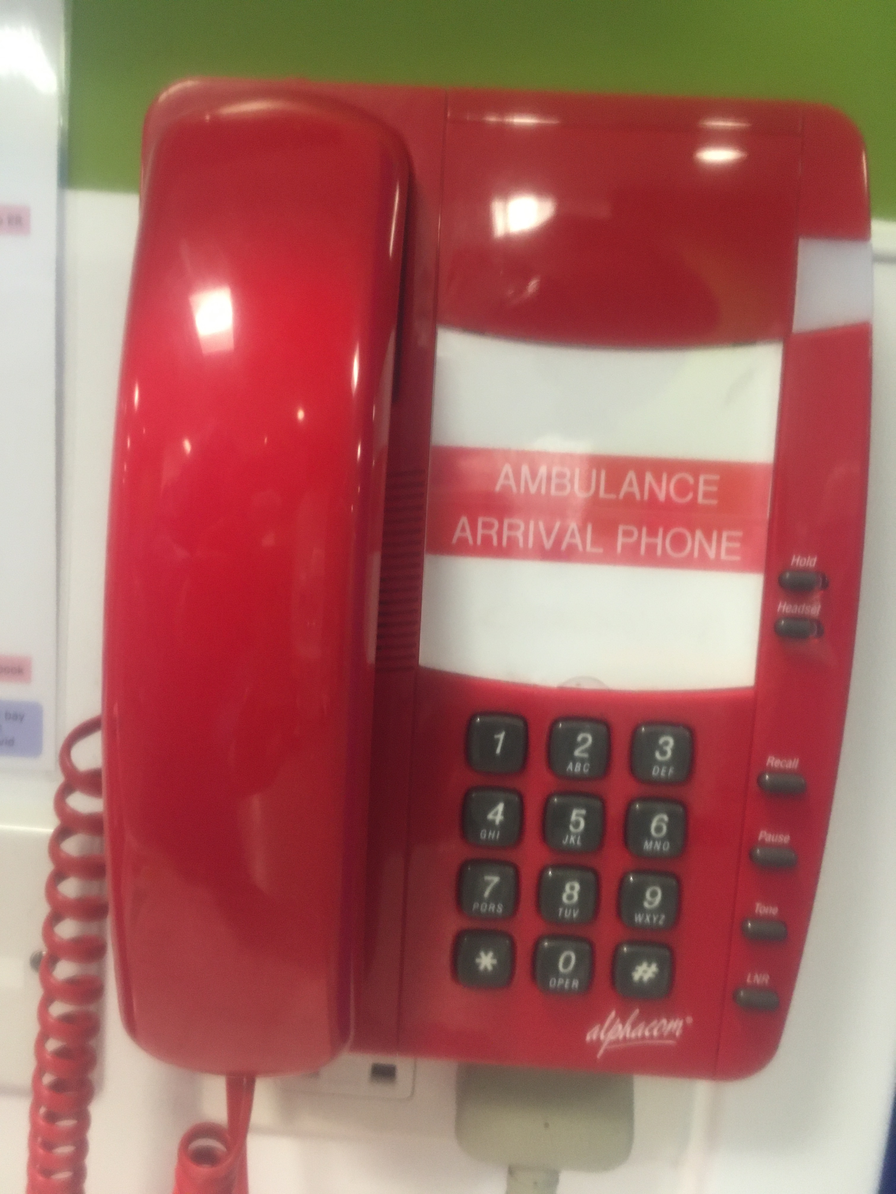

**4) Push the ‘Headset’ button again to finish the call.**

**5) Take both Headset and Microphone off before you walk away!**

**Headset**

**Throat Microphone**